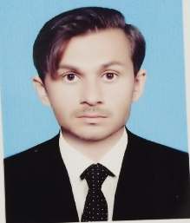Zain ul Abidin

BSpalology

# About Me

Contacts

 Address

Azim Killa Purana tehsil Domal district Bannu

 Phone

03440928303

 E-mail

[Zainabidin763@gmail.com](mailto:Zainabidin763@gmail.com)

Skills

Good practice in clinical pathology and Serology, heamotology, Chem try, microbiology, phlebotomy

# Interests

Football, Cricket, English moves, and Pakistan dream.

Languages

English, Urdu, paahto.

## Education

Schools 2013 to 2015

Completed SSC from wisdom science

college chokara karak with

College 2015 to 2017

Completed FSC pre medical from Bradford science college chokara karak with

Graduadon 2017 to 2021

Completed BS pathology from Northwest institute of health science Peshawar with

Work / Experience

Northwest general hospital Peshawar (clinical rotation)

Combined Military Hospital Peshawar (CMH)

Peshawar institute of medical science (PIMS) Peshawar

References

1. Dr. Imran Khan, Assistant professor, Department of pathology at northwest institute of health science Peshawar

Cell No:+923329502035

1. Naeem Khan Assistant Professor, of Nerthwest institute of health science Peshawar

Cell No:+9203431996495